Utilization of algorithm ,dynamic programming,optimization

dynamic programming is an optimization approach that transforms a complex problem into a sequence of simpler problems; its essential characteristic is the multistage nature of the optimization procedure. More so than the optimization techniques described previously, dynamic programming provides a general frameworkfor analyzing many problem types. Within this framework a variety of optimization techniques can be employed to solve particular aspects of a more general formulation. Usually creativity is required before we can recognize that a particular problem can be cast effectively as a dynamic program; and often subtle insights are necessary to res**igure 11.1** Street map with intersection delays.

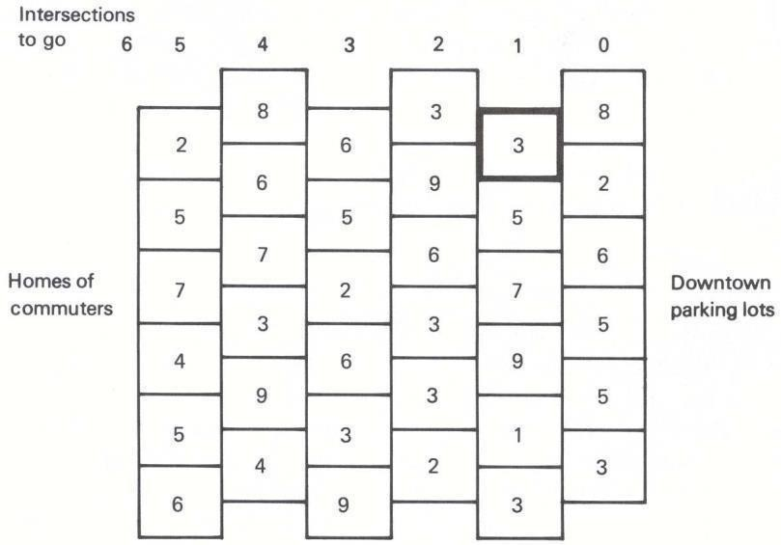

**Figure 11.2** Compact representation of the network.

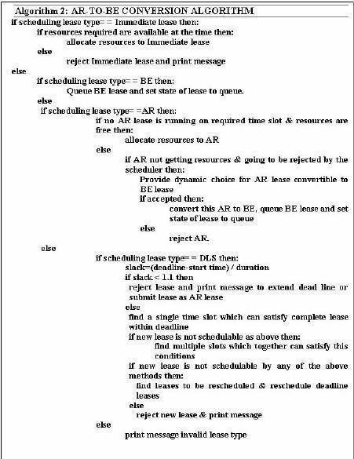**322 Dynamic Programming 11.1**

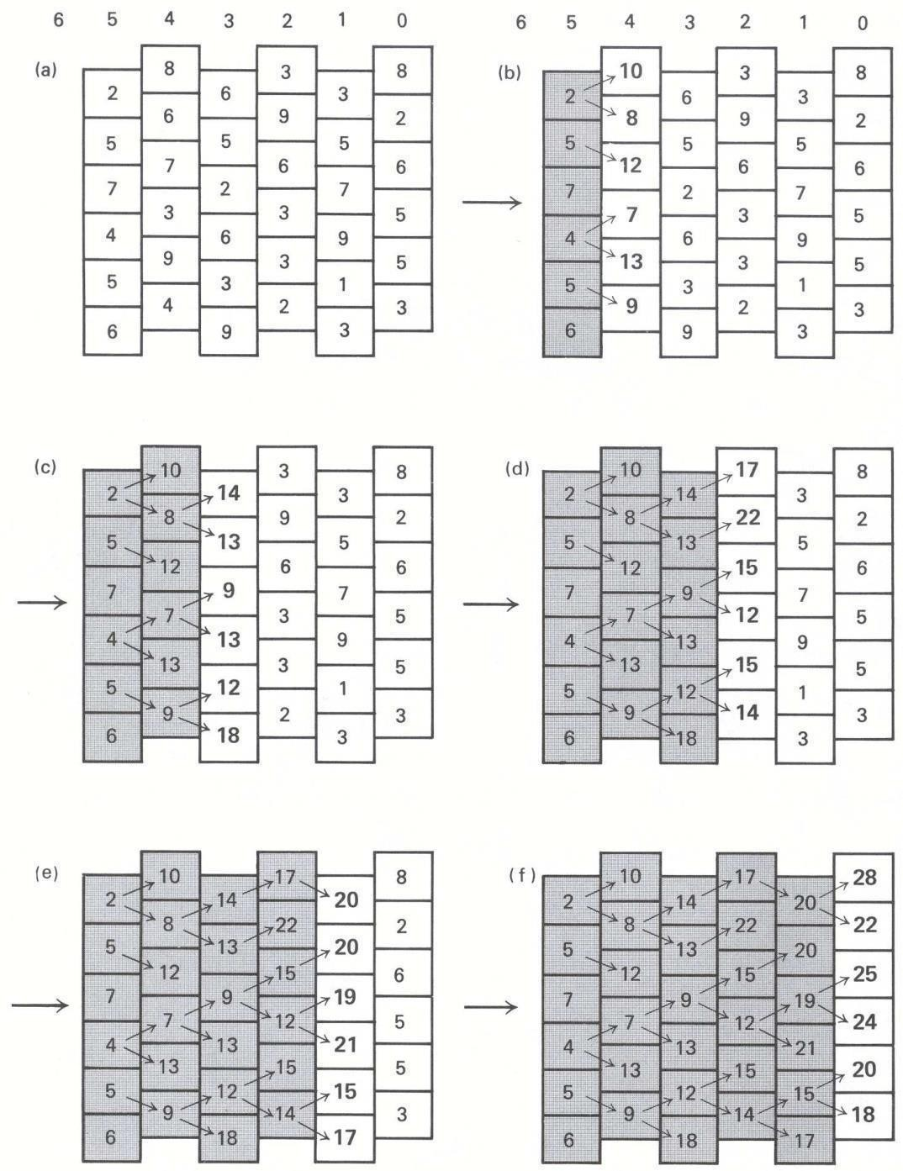

**Figure 11.6** Solution by forward induction.

**Exercises 335**

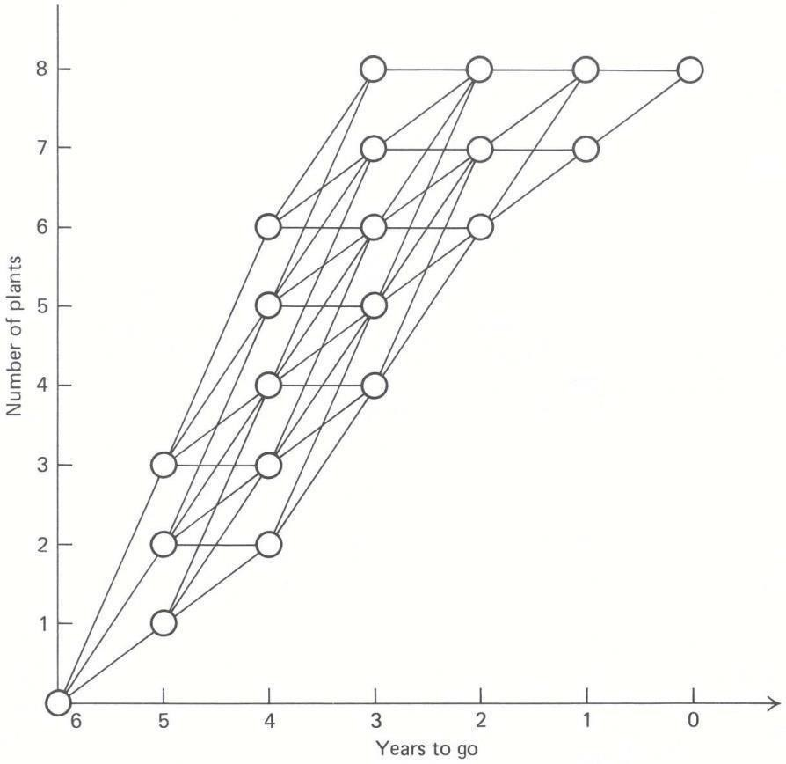

**Figure 11.8** Allowable capacity (states) for each tage

plus the plant costs, which depend upon the year of construction and whether 1, 2, or 3 plants are completed. Measured in thousands of dollars, these costs are

1500 + *cnxn,*

the one additional plant is the $1500 common cost plus the $5200 cost per plant, for a total of $6700. (All costs are measured in thousands of

dollars.) The column headed *d*1∗*(s*1*)* gives the optimal decision function, which specifies the optimal number of plants to construct, given the current state of the system.

Now let us consider what action we should take with two years (stages) to go. Tableau 2 indicates the possible costs of eachstate:

**Tableau 1Tablea**

